

Name Abdul Rahim

Roll No 2K24/CSE/14

Assignment Topic Visual Breakdown

Subject HCI & CG

Submitted to Sir Rajesh Kumar

Image 1 — HCI Focus (Need for Speed)

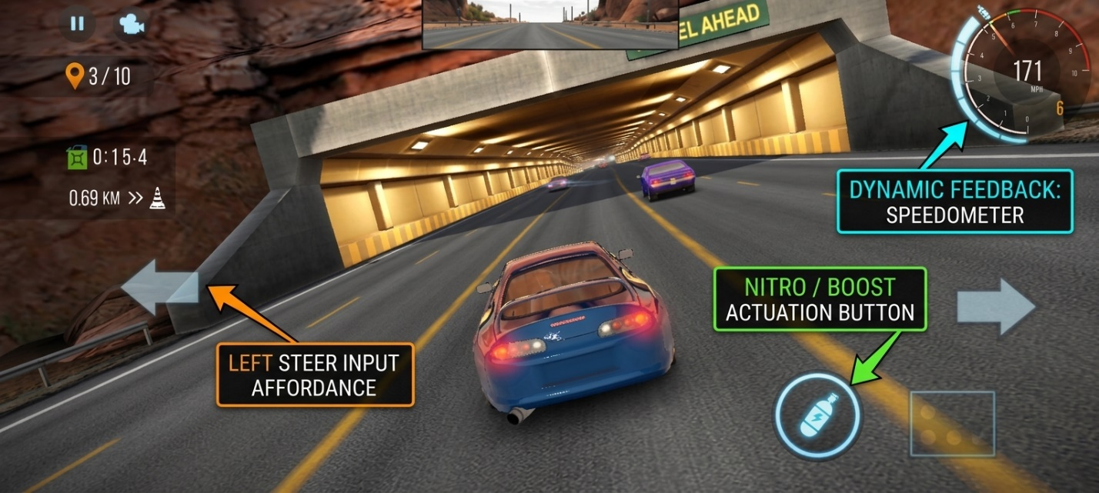

- Steering Controls — Left & Right Arrows :
The large left and right arrow buttons allow the player to steer the car. They provide a clear and easy way to control the car's direction.

2. Nitro Control — Nitro Button:
The nitro button at the bottom-right allows the player to activate a speed boost. It gives the player direct control over acceleration during the race.
3. Dynamic Feedback — Speedometer & Race Position:
The speedometer (171 MPH) shows the current speed, while 3/10 shows the player's position in the race. This gives immediate feedback about the player's performance.

Short caption for your image:
HCI elements make the game interactive and user-friendly by providing clear controls and immediate feedback to the player.

Image 2 — CG Focus: Rendering / Visual Elements

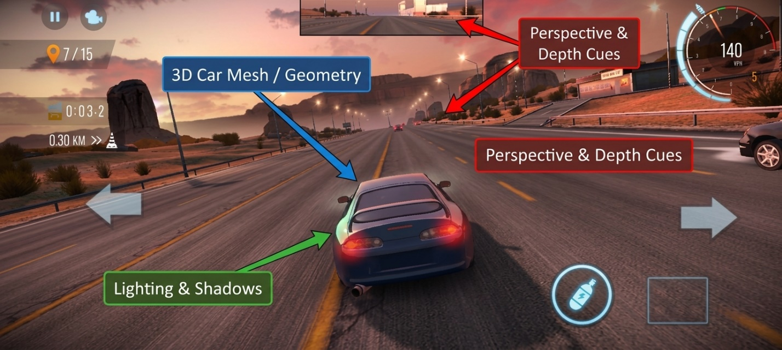

- 3D Car Mesh / Geometry :
The blue car is modeled using 3D geometry, including its body, windows, wheels, lights, and curves. This gives the car a realistic three-dimensional shape.

2. Lighting & Shadows :
The car and road have light reflections and shading. The highlights on the car and darker areas underneath/around objects make the scene look more realistic.

3. Perspective & Depth Cues :
The road and cars become smaller as they move farther away. The road lines converge toward the distance, creating perspective and a strong sense of 3D depth.

Short caption for the image:
Computer graphics techniques such as 3D geometry, lighting, shadows, and perspective create a realistic 3D racing environment.

Answer 2 Short Reflection Questions (3-4 sentences total).

Q1. How does the Computer Graphics quality (e.g., realistic lighting or 3D view) help or hinder the user’s ability to interact with the software?

ANSWER 1.
High-quality Computer Graphics like dynamic lighting, ambient shading, and clear 3D perspective enhance the user's spatial awareness and immersion, making speed and distance estimation more intuitive during gameplay. However, excessive visual detail or realistic glare can occasionally clutter the view and distract from critical HUD elements like steering affordances and speedometer readouts.

2. What is one simple HCI change you would make to improve the user interface?

ANSWER 2.

To improve the user interface, I would increase the opacity and visual contrast of the steering arrow overlays so they stand out more clearly against light-colored environment backgrounds like the sunset road.

